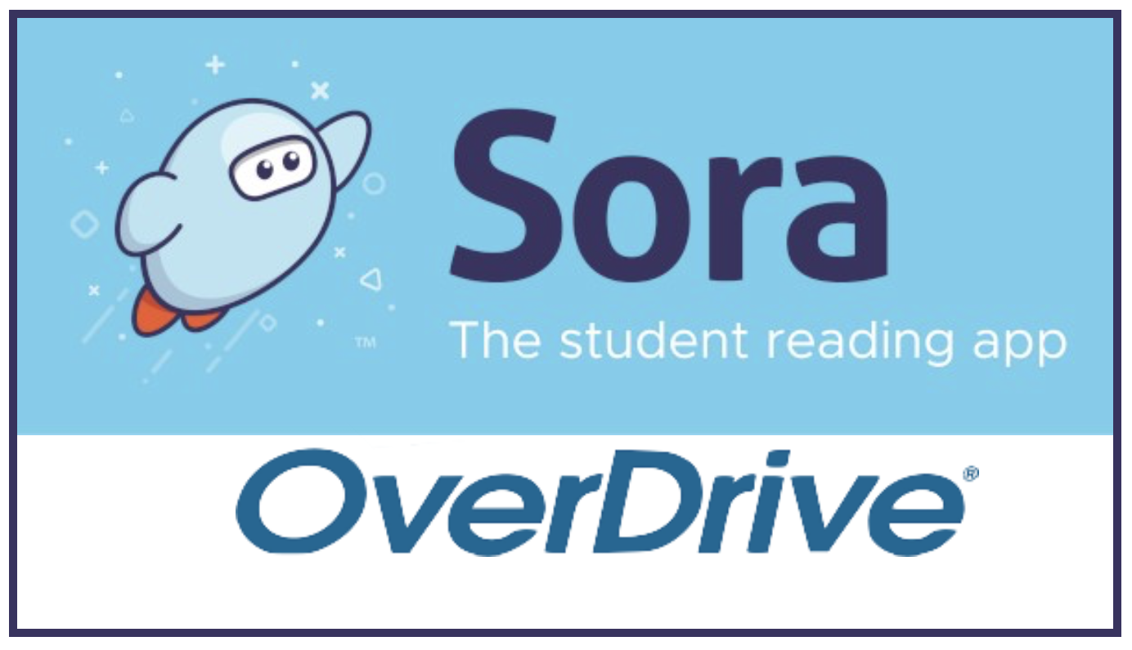

BCE parents,

We want you to be aware of a new app that you can use at home with your students for online books. It is similar to the OverDrive app you might use currently through the county library.

One of the resources you will see is the Beehive books for the 2021-2022 year. The county is once again doing the Beehive Book Award program, watch for information to come out from the school or stop by any county library for information.

The sign-on information to use the app is their email address they use at school.

