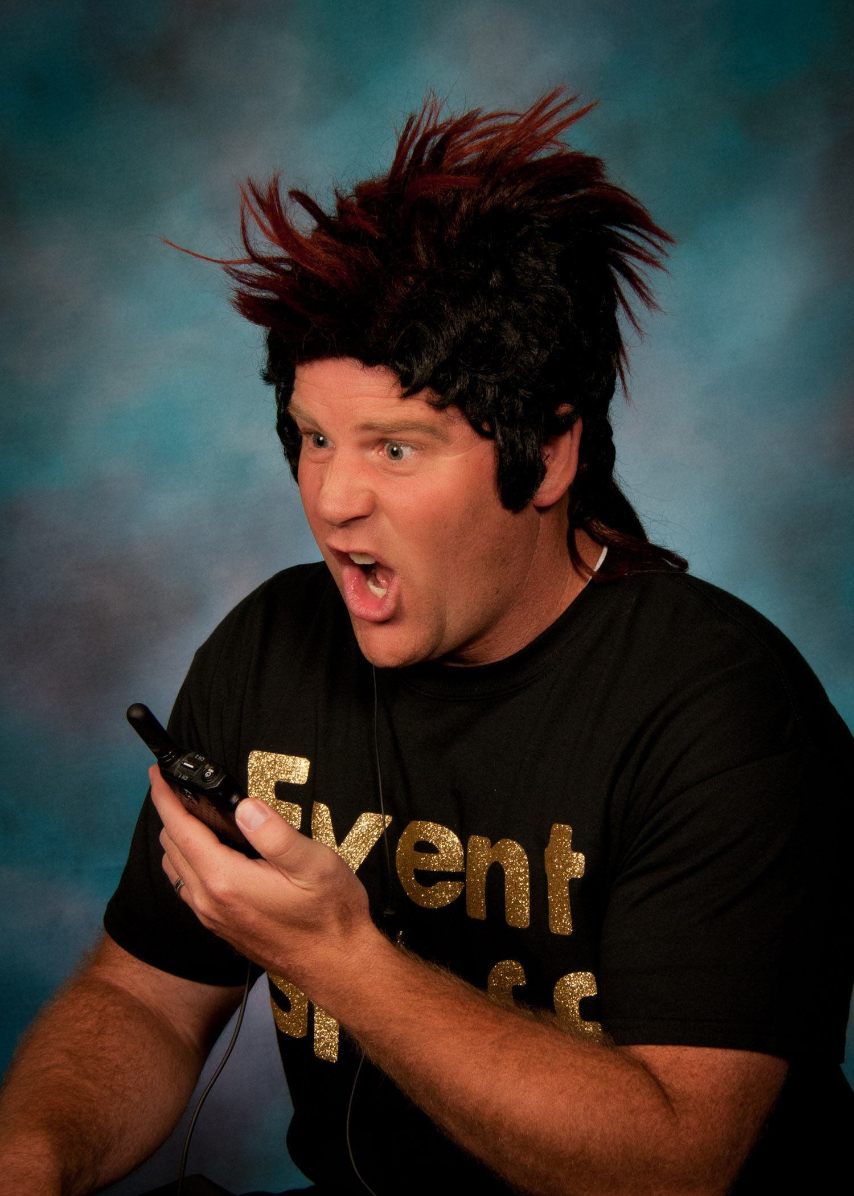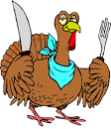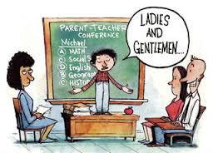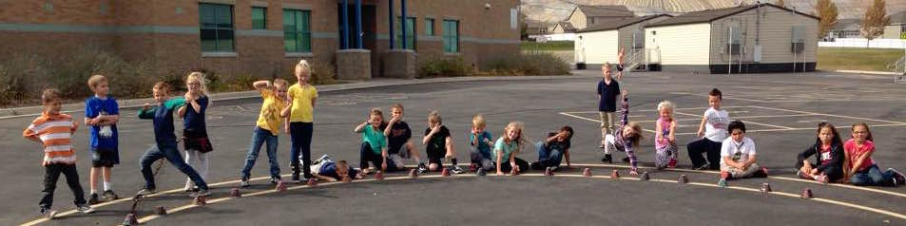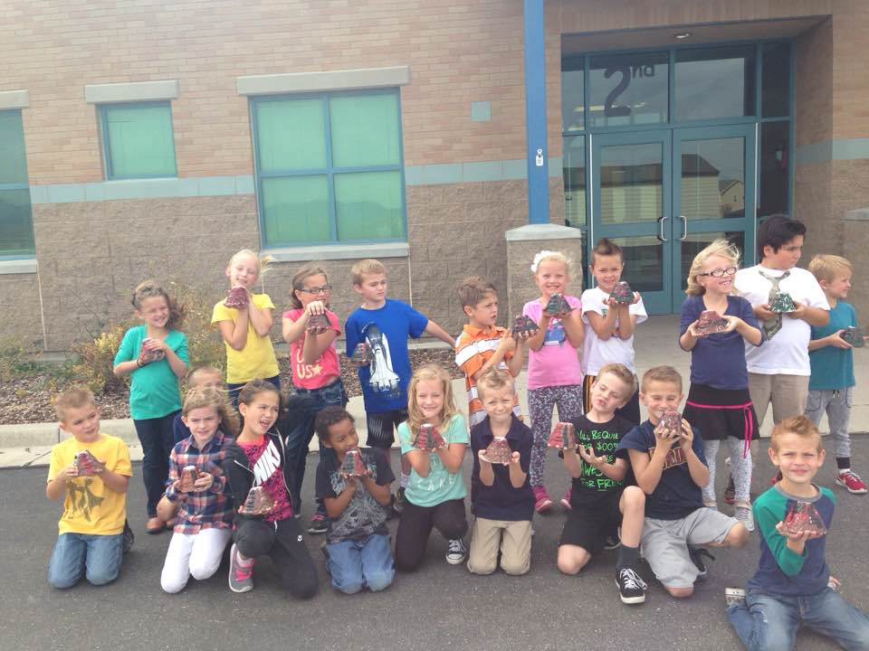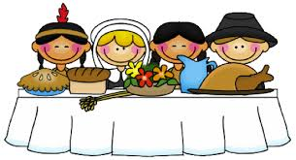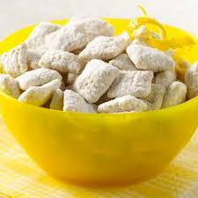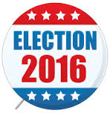

Story Telling Festival

Thursday, December 1st starting at 2:30.

No School on November 23, 24, 25

Full Day on Tuesday, November 22

### Vivamus leo nunc, blandit convallis, dapibus a, hendrerit sed, velit.

# A note from our Principal, Mr. Hansen

Happy Thanksgiving!!

November Issue

Bobcat Bulletin

A Kid’s Perspective

by: Caroline Morris

How was your parent teacher conference? That’s the exact question I asked one student from each grade. Here’s how they responded.

“Good. I got my leadership notebook and showed my mom my progress.”Addison Morris 1st

“Good.We talked about my report card.”Gracie Richter 2nd Grade

“Good.I got my student lead PTC paper and told my mom how I was doing in school.”Maggie Morris 3rd Grade

“Good.We talked.”Norah Pack 4th Grade

“It was very good. I got a mint and went to the book fair.”Ashlyn Heaton 5th Grade

“Good.We talked.”Griffin 6th Grade

## Student Led Conferences

What’s up in the lower grades? grades?

wh

We made volcanoes in 2nd grade.  We painted them so it would look like a volcano and we sprayed them so they wouldn't be ruined when the lava oozes out.  We put baking soda and vinegar so it will ooze out.

By Kestler Hagen

Teacher Spotlight:

Mrs. Ricks

by Kenadee King

Hi! Here at Butterfield Canyon things are great! But guess who just made the school better? Mrs. Ricks! She’s the new 2nd grade teacher here. Here’s just a little bit about Mrs. Ricks. Kenadee: “What’s your favorite color?” Mrs Ricks:” Teal.” Kenadee: “What’s your favorite animal?” Mrs. Ricks: “Frog, when I was little I collected lots of frogs things, I even had a frog themed bedroom. K: “Cool! Where did you graduate from?” Mrs. Ricks:”BYU Idaho.” K: “I’ve once been there! Why did you move here?” Mrs Ricks: “I moved here because my husband’s job needed more people here in Utah for work. So we moved here to Utah.” K:” Do you have any pets?” Mrs. Ricks:” No. I’m actually really afraid of animals.” K: But what if you had a pet? By the way fish are really easy to take care of.” Mrs. Ricks:” Hmmm… it would have to be a Bada fish.” K:” What are your favorite foods?” Mrs. Ricks:” Costa Vida, and Mexican food.” K:” Good choices. What’s your favorite treat?” Mrs. Ricks: “ Brownies and ice cream.” K:”What’s your favorite ice cream?” Mrs. Ricks:” Utterly Chocolate and Tonight Dough.” K:” What’s your favorite drink?” Mrs. Ricks:” Diet Mountain Dew.” K:”What’s your favorite game?” Mrs. Ricks:”Nertz.”  (It’s a card game.) K:”What’s your favorite  part about being a teacher?” Mrs. Ricks:” When students struggle, then later on that light clicks on in there head. I also love singing with my class.” K:” Fun! What’s your favorite part about BCE?” Mrs. Ricks:”All the students are such great leaders and are respectful.” K:” If you could live anywhere in the world where would it be?” Mrs. Ricks:” Italy.” K:” Awesome! Have you read the Harry Potter series?” Mrs. Ricks:”All the book’s.” K:” I’m on the fourth Harry Potter book right now! What’s your favorite series of book’s.” Mrs. Ricks:” Unfortunate Events and The Giver.”  K:” What’s your favorite subject?” Mrs. Ricks:” Science.” K:” Good choice. Do you have any siblings?” Mrs. Ricks:” Yes. I have three brothers and four sister’s. K:” Wow! If you had four wishes what would they be?” Mrs. Ricks:” That’s hard. Hmmm… eat Costa Vida and not get fat, no homeless people, cure cancer and pay off my school loans.” K:” Those are are great wishes.” Here are are some Fun Facts about Mrs. Ricks:

She loves Netflix, cooking, camping, taking naps, shopping at Costco, brussle sprouts, asparagus.

She was married in 2011 to her husband, Tug.

She has a crush on Patrick Dempsey, don’t worry, her husband is fine with that.

She likes the show Gray’s Anatomy.

She likes the singer Ingrid Michaelson

.

  THANKSGIVING HISTORY

by: Olivia Dinkelman

When you think of Thanksgiving, you probably think of roasted turkey, stuffing, mashed potatoes, pumpkin pie, and many more delicious foods. But what you may not have known about the Pilgrims and the Wampanoag people, were the founders of this delicious feast. Thanksgiving actually started out as a way to celebrate the harvest every fall. People do fun things during Thanksgiving, like, make tasty special foods, eat a big meal with family and friends, watch a Thanksgiving day parade, and/or watch football games on TV. what are some special traditions you do with your family?



Ingredients:

9 Cups Rice/corn Chex

1 C. Semi-Sweet Chocolate chips

½ Cup Peanut Butter

¼ C Margarine

1 tsp Vanilla

1 ½ C Powdered Sugar

#### Muddy Buddies

Directions:

1. Place cereal in bowl and set aside.
2. In 1-quart microwaveable bowl, microwave chocolate chips, peanut butter and butter uncovered on high. Stir, microwave 30 seconds more or until mixture is smooth. Stir in vanilla, pour mixture over cereal, stirring until evenly coated. Pour into 2 gallon re-sealable plastic bag.
3. Add powdered sugar, seal bag and shake until cereal is coated.

The Presidential Election

                       By Emma Scott

On November 8, 2016 Donald J. Trump was elected president of the United States of America. I asked students how they felt about this. This is what some of them said.  Lillian M. from Ms. Thorn’s fifth grade class said, “I think we should have an open mind about this and have high expectations.  He should pay back China.”  Rylie R. from Ms. Thorn’s class said, “It’s odd, because I’m used to Obama.” Jacob S. from Mrs. Yocum’s third grade class said, “I hope that he’s a good president and makes our country a great place. I hope that he won’t do anything bad.”  A Butterfield Canyon parent said, “He has been elected president and I hope that he will make good choices that will benefit everyone in our country. I hope that he will try to bring our country together.” That's it for this month.

Jordan School District Board

By:Tyler Betteridge

This year we’re voting on a new candidate for the Jordan School Board in our district. A district school board is responsible for:

“-employing the superintendent

-developing and adopting policies, curriculum, and the budget;

-overseeing facilities issues; and

-adopting collective bargaining agreements.”

As of right now, Darrell Robinson has the most votes. Here are some things he wants to do on the board:

1. Cut back on standardized testing.
2. Innovate math classes.
3. More blended learning and more creative classrooms

He has many more ideas on his website: [www.darrell-robinson.com](http://www.darrell-robinson.com). I encourage you to check it out!