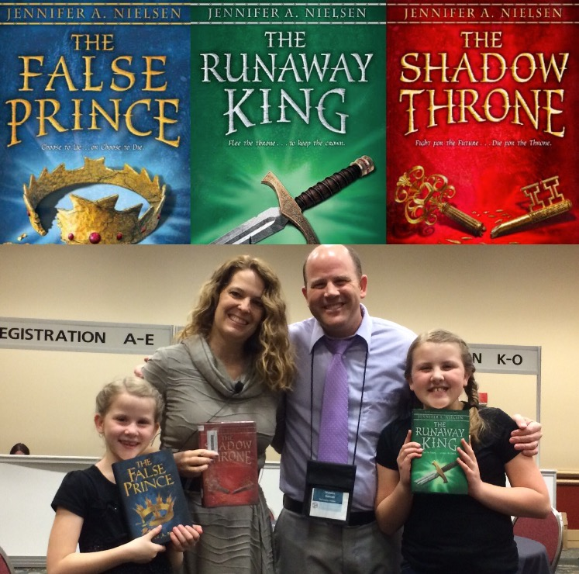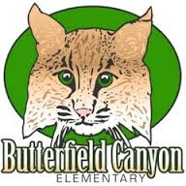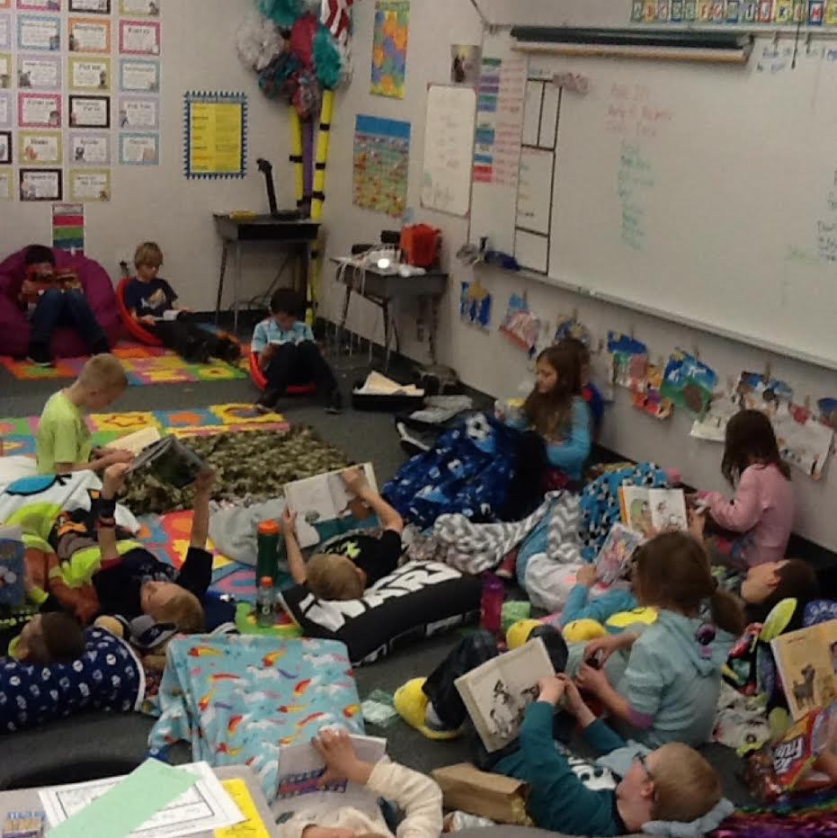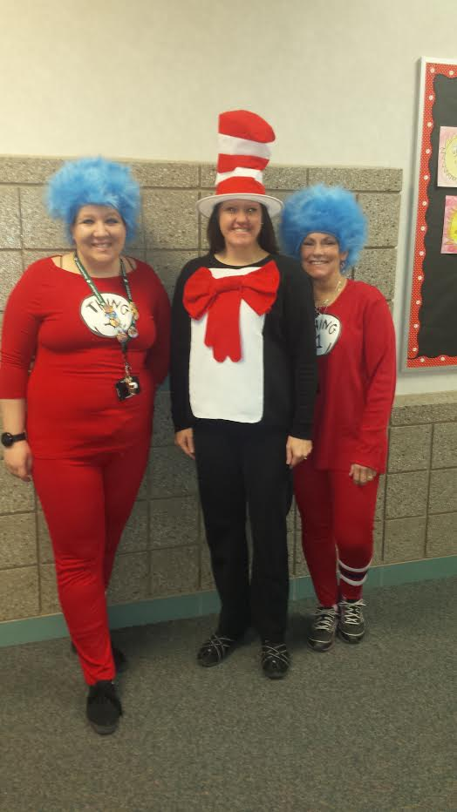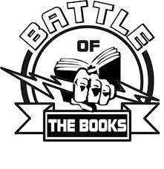

My Fellow Bobcats,

The picture above is me and my two daughters with the author of the Ascendance trilogy, Jennifer Nielsen. She is a super nice and talented local author who signed our school's copy of the book. I read all three of them and would highly recommend them to our 5th and 6th graders.

We have some exciting events coming up at our school! On top of all the amazing grade level programs you've been working on, we have some fun programs for our upper grade students coming up in the next month: the Battle of the Books, Math Wars and the Science Bees.

Top **Battle of the Book** teams will be headed to Momentum and Funtopia gyms for an incentive field trip on March 29th. Remember to demonstrate good sportsmanship, develop a team cheer, and have fun with the battles. You guys crushed our goal of reading 300,000 pages in BOB books this year - we're almost at 500,000 pages! So yes, you will see Mr. Hansen get slimed with goop because you met your goal! Know that the winning BOB teams from our school will battle against the winners from Silver Crest Elementary and the winning school gets to keep the trophy at their school for the entire next year.

**Math Wars** will be a super fun way to review math this year. There will be a team and an individual component. You'll be able to dress up in Star Wars style clothing on those days as you move from planet to plant putting your Jedi training to the test.

The **Science Bee** will be happening as well after spring break. Be sure to take time to carefully review the math and science study guides that you'll be provided with. We are offering an incentive Magic Show assembly for ALL students who do well on the individual math test or science test. We hope everyone in 3rd-6th grades will be able to attend. If you qualify for the assembly for both the math and science you will be able to sit in the VIP section in the front and have extra snacks.

Remember that you are each destined for greatness. Greatness is within each of you. Do you best, study hard, and don't give up. You've got this!

- Mr. Hansen

March 2017

# A note from Mr. Hansen

4th Grade Science Expo

3rd Grade Program

5th Grade Maturation

## Upcoming Dates

Bobcat Bulletin

pg. 3

BOB Battles

March 30

Mar. 20-24

March 28

March 31

On Monday we had Cat in the Hat day.  We drew the Cat in the Hat.

Tuesday was Green Eggs and Ham day.  We wore green.

Wednesday we had Fox in Socks day.  We read the book and made a crazy sock.

Thursday was Read Across America day.  We dressed up as a favorite book character.  Friday we had pajama day.

Second Grade Celebrates “Read Across America”

by Kyson Rogers



History of Leprechauns

by Tyler Betteridge

Have you ever tried to catch a leprechaun? Legend has it that if you catch one it has to give you its gold. Have you ever wondered how the legend started?

The myth came from Ireland. Before other religions were brought to Ireland, the Irish believed leprechauns were gods called Tuatha De Danann in fairy form. The legend says that they were usually mean little creatures. The Irish kings and queens were thought to be descendants of the Leprechauns so they were treated like gods.

The Irish thought that if you caught one you were extremely lucky so they made the four-leaf clover, a symbol of luck, the Leprechaun’s symbol. Then, they thought the Leprechaun’s celebration, which later became St.Patrick’s day, should be in the spring because clovers are green and green is the main color of spring. That’s why St.Patrick’s day is in March.

Throughout time the legend changed to the legend you hear around March seventeenth, or St.Patrick's day. It says Leprechauns are tiny, greedy, and own pots of gold. It also claims if you catch one it’s forced to give you its pot of gold.

This St.Patrick’s day,set out your traps and see if the current legend is true.



How to Prepare for Battle Of the Books

by Kenadee King

Hey everyone!!! It’s Kenadee, and this month I get to write about how to prepare for B.O.B! I have interviewed my friend Gwendolyn Soffe on how she’s preparing for B.O.B!

“So tell me Gwendolyn, how are you preparing for B.O.B this year.” Here's her response to my question. “I read one book after another, and I read them every day for my reading. I also have free nights where I can read the “Harry Potter series.” says Gwendolyn Soffe.

“Great!!! How else are you preparing for B.O.B?” asks Kenadee

“I keep up with my B.O.B group, and ask them what books for B.O.B there reading, so I don’t read the same book’s and make sure that my group does not read the same books over again and not improve the number of books we have read.” states Gwendolyn Soffe.

This is just one example on how to prepare yourself for the battles!!! Don’t forget to study the titles and authors!!!

Secret Service Project

By: Caroline Morris

On March 7, 2017 around 9:15, posters were being hung up all over the copy room. Why was this happening? Because a secret service project was in progress. About a month before I had this idea to do a service project for the aids. They do so much for us so i thought it would be a good idea to do something nice for them. I made a big poster with my friends that said “thank you.” Then I wrote a letter to the team leader of each grade asking them to tell all the teachers in that grade to write a letter. A plan was being made. My teacher, (Mrs. Jaroscak) ,emailed all the teachers asking them to bring the letters to my portable. We got so many letters! They were amazing. We got letters and posters and candy on posters. On the morning of Tuesday, March 7, my friends and I took all the posters and letters we had gotten down to the copy room. The aids don’t get until 11:00 so we had time. Mrs. Schmidt was down there helping us. We put up the poster and letters all around the room. Later, when the aids came, I got to see their reaction. It wasn’t a very big one though. Later that afternoon, Teresa told me that, “We really loved it, but there was a copy guy there and he isn’t very nice.” So, it turns out that my friends and I actually did a pretty good job and that they really did love it. I would like to thank all of you guys because you guys are really the ones that made this all happen. Thank you so much.

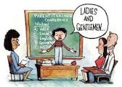

How to prepare for Student Led Conferences

### **By Olivia Dinkelman**

Step #1: get good grades

Step #2: prepare your parents by telling them what they will find out at conference

Step #3: look at the differences from this term and last term and remember all you have learned

Step #4: remember your grades last conference and have a growth mindset

Step #5: go to your conference

Step #6: (optional) convince your parents to take your out for ice cream.