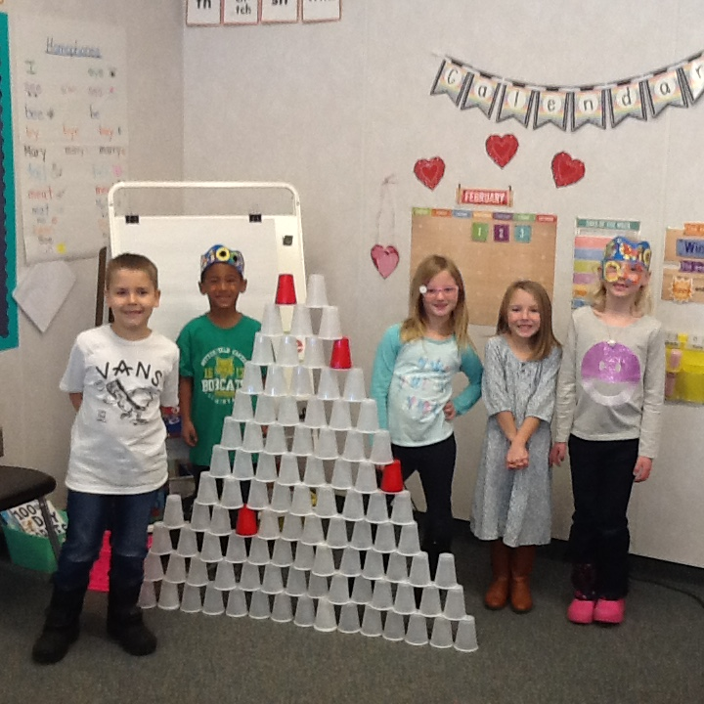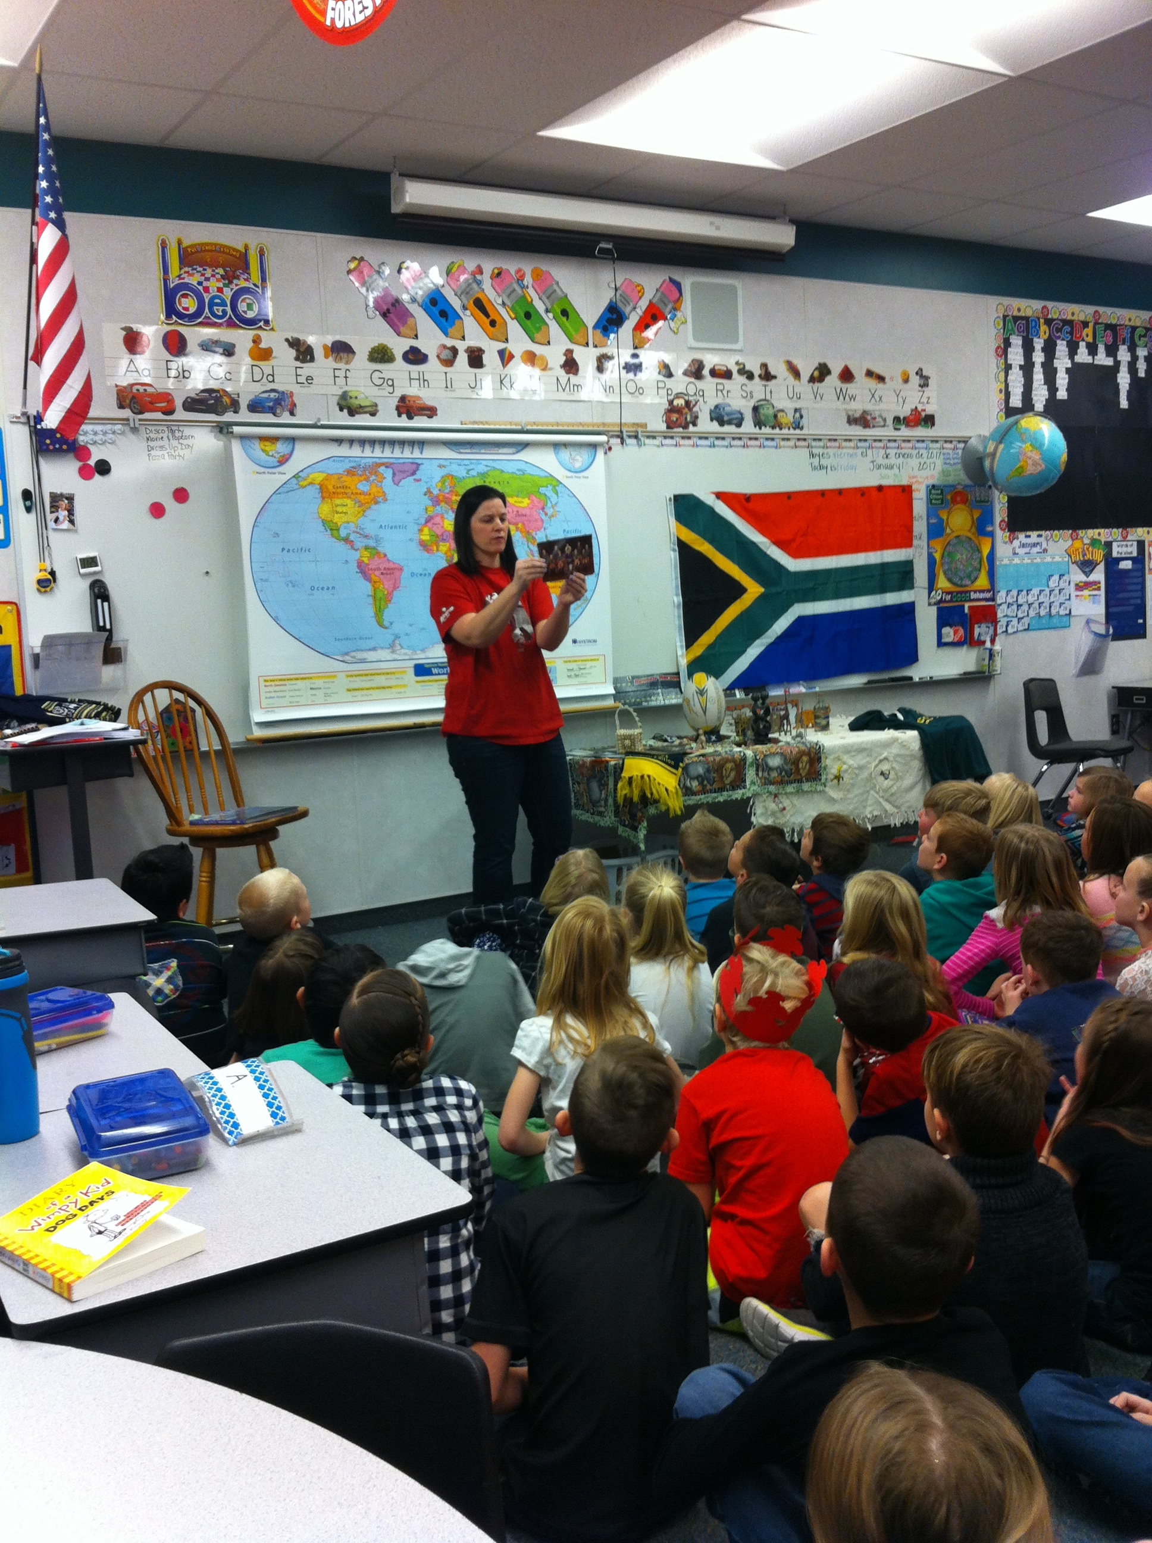

Hello Bobcats!

Thanks for working so hard this year. Keep bringing your “A game” to everything you do. That means make sure your effort and attitude are the best you’ve got so that you would get an “A” grade in whatever you do.

You will be taking a survey in the computer lab to provide feedback to your teacher and the principal on how you think things are going here at Butterfield Canyon. We care what you think and will look forward to reading your comments. Your parents will also be taking a survey at home about the school. If they sign your paper indicating that they took the survey, you can bring that paper down to the office when the teacher says it’s a good time to claim your prize and be entered into a drawing for a family pass to the Discovery Gateway or a $25 gift card at the book fair.

Remember that good attendance is important. If you’re late or absent – you are missing out on valuable instruction and important classroom activities.

Keep up the good work to let the leader in you shine through!

Choir Assembly

# Principal’s Notes

February 2016

Bobcat BulletinF

Night of the Arts/Choir Performance 5:30-7:30

President’s Day, no school

February 20

February 15

February 16

## Important Dates

Second Grade Travels Around the World

by Kestler Hagen

We went to six countries: 1) Peru 2) Philippines 3) Australia or the land down under 4) Egypt 5) Sweden 6) Guatemala.  We had fun learning about different countries.  My favorite was the Philippines.  It's made up of lots of islands.

First Grade

On February 3rd, our class celebrated the 100th day of school! We did five centers. One of them was to build a structure using 100 cups. Another one was to draw what you think you will look like in 100 years. Another center was to make a 100 piece puzzle. Another one was to count by 10s and put ice cream scoops on a cone. The last center we did was to add 100 paint dots on a gumball machine. Now you know what we did for the 100th day of school!

By, Dylan Dilley 1st grade, Mrs. Hernandez’s class

### Cub Corner



The 5th grade had a D.A.R.E graduation on January 24, 2017. It was really cool. I should know because I was there. In the morning everybody who graduated got to go to Texas Roadhouse. At Texas Roadhouse we got to make our own rolls, learn how to line dance, got a tour of their whole kitchen, and ate lunch. We had a D.A.R.E essay contest. There was one winner from each class. The winners were Mikayla Loader(Thorn),Lauryn Pelch(Frost), Jake Johnson(Masina), Adelaide Nelson(Chambers), and Caroline Morris(Jaroscak). After the winners read their D.A.R.E. essays everybody who graduated got their certificates. Our D.A.R.E. officer was Officer Jake Cutright. One of the special guests we had there was the mayor. We were supposed to have a special speaker but she never showed up. Officer Jake told us a little bit of her story and it was very inspiring. The whole fifth grade sang a D.A.R.E. song that is called “I Will D.A.R.E.” It is very catchy. At the very end we watched a special D.A.R.E. video.  The D.A.R.E. graduation was so much fun.

**D.A.R.E. graduation**

In January the fifth graders had a D.A.R.E. (drug abuse resistance education) graduation. First the fifth graders all went to the restaurant Texas Roadhouse for lunch, a tour ,and a line-dancing lesson. Then they took a bus ride back to school and walked to the gym. Officer Jake invited special guests (who arrived later) including the mayor, and the police mascot. The fifth graders all shook each guests hands. Each fifth grader received a certificate showing they had graduated D.A.R.E. Finally, everyone watched a video about Daren’s elementary years and experiences with drugs.

# 5th Grade D.A.R.E.

# Graduation

# By Caroline Morris and Tyler Betteridge

Inauguration Day

By Olivia Dinkelman

Inauguration day is in January, after a new president is chosen. It is when the president gets sworn in, which means he or she promises to be a good president and do good things. Every four years since 1789, a new president has been chosen. Some inaugurations will never be forgotten. Some examples are George Washington’s second inauguration on March 4, 1793, with the shortest address given with only 135 words! William Henry Harrison , who was sworn in on March 4, 1841, had the longest address with 8,445 words. The second inauguration of Ronald Reagan was the coldest, at seven degrees with the wind making it feel like -10 to -20. The first inauguration of Barack Obama on January 20, 2009, had the largest attendance and he was the first African American to be sworn in. This year, Donald Trump, the Nation’s 45 president was sworn in. He has been a politician, been an extra in many movies and TV series. Here is what some kids at our school think about this year’s inauguration day and Trump being president………

Ashlyn Parker in fifth grade says that she did not like Donald Trump and was upset that he won.

Lilly Keller in fifth grade says she does not care because she did not like Hillary Clinton or Donald Trump.

Lily Dinkelman in first grade says that she likes Trump and did not like Hillary, so she is happy

Atlanta Dinkelman in third grade does not really care. Why, you ask? I have no idea.

Personally, I did not like either candidates.

                     Movie Review! Trolls

by Kenadee King

Hey it’s Kenadee! This month I get to write a movie review about “Trolls!” I really like this movie for many reasons, 1st: It’s so funny and on some parts touching. 2nd: It teaches you some lessons, such as: You don’t need money or toys to make you happy, all you need is family and friends! 3rd: The rating really fits it (PG) and also the songs are really good and funny at some points. This movie is so good! There are some parts where it will not make sense but if you see a second time it will make sense. Like for me I’ve seen it twice!!! Everybody should see it!! Old, young, in between, everybody!!! When I saw it (WARNING: Don’t EVER try to make me laugh so hard, you won’t like it at all!!!) I laughed so hard I cried/ laughed! My three younger sisters (Kambree, Berklee and Preslee) all loved it too!!! My mom and dad also really enjoyed it as well! It may not look like a good movie, but don’t judge a book/movie by it’s cover.

Favorite food: sushi, pizza, chocolate

Favorite color: mint blue

Favorite movie: Pride and prejudice

Favorite subject : Math

Favorite book: The Lion, The Witch, and The Wardrobe

Favorite sport: rock climbing

Favorite vacation: Hawaii and Disney world

Teacher Spotlight: Mrs. Yocum