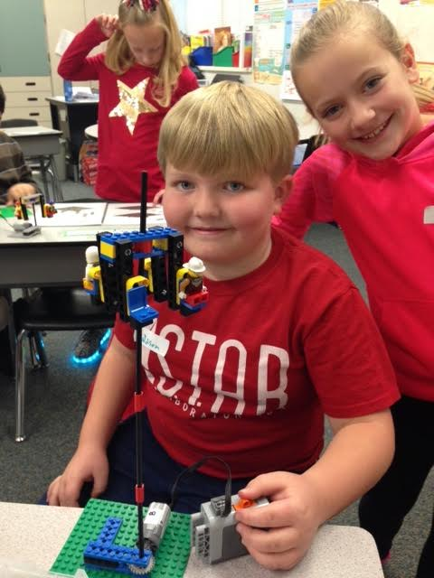

Dear Bobcats,

Butterfield Canyon is such a great place to learn! The teachers are super friendly and prepare well to make learning fun. The students here are super impressive. They are well behaved, care about other people, and they work really hard.

It was super fun to see the 1st-3rd graders put on "The Littlest Christmas Tree" performance. It was fantastic and super cute. There were adults in the back of the gym crying because everyone did such a good job and the message was so touching. It was Hallmark channel quality! Kudos as well to our upper grade Orchestra students who are learning to play a new instrument. Way to stick with it! They have a Christmas performance for their parents this week and at some point this year we will hear them live. Can't wait!

One thing I want to remind some of the Bobcats new to our school about safety is that you want to be sure to always cross the street at a crosswalk where possible. I have seen some close calls in the back and front of the school. I am currently working with the DARE officer and Herriman City workers to create a safer plan for the back of the school, but in the meantime please take the extra steps so you can cross at a crosswalk if there is one nearby.

I was so happy that we reached our goal of collecting enough food for the hungry to fill all 10 bins. Well done Bobcats! I told the service club students in the 3rd grade that if we met our goal that I'd be willing to be duct taped to the wall during lunchtime. You all saw me in there last week. I was up there for almost an hour and a half. It was actually kind of fun and I was totally happy to do it. You kids are pretty awesome! Keep it up. Remember that you've got what it takes and you can do hard things. Always be a buddy, not a bully and don't forget to let the leader in you shine through! Be sure to keep your holiday Merry and Bright! See you in 2017!

# A note from our Principal, Mr. Hansen

Bobcat Bulletin

The

Christmas Traditions Around the World

By: Tyler B.

Many people celebrate Christmas around the world. For example ,some celebrate by decorating a pine tree and hanging stockings over the fireplace. In Spain people go to Midnight Mass or `La Misa Del Gallo` (The Mass of the Rooster.) In China only one percent of people are Christians, so they only celebrate in major cities. In France a nativity crib is often used to decorate the house and Santa is called Pere Noel. In Argentina the houses are beautifully decorated with lights and wreaths. Even though we celebrate christmas in different ways the spirit of Christmas is still the same.







In December the 2nd grade did a lot of STEM activities.  That means science technology engineering and math.  We made parachutes for Santa, shelves for elves, and giant Christmas trees.  Here Widdison is making a carousel ride for Legos guys.

By Kestler Hagen

What’s happening in 2nd Grade?

What are you doing for Christmas? Do you know what you want? Well, you’d better think about it. Christmas is getting closer. I interviewed a few students from our school about their Christmas and this is what they said:

Mya Peme in kindergarten doesn’t know where she is going for Christmas yet. She wants a stuffed animal cat, dog, and Playdough for Christmas.

Brennan Parry in first grade wants a dirtbike and Legos for Christmas. He is also going to his grandma’s.

Courtlin Atkinson in second grade wants American Girl stuff and a journal that locks. She is staying at home in her cozy house for Christmas.

Haley Thomas in third grade wants an i-pod with just music. She puts up a Christmas tree with the ornaments up high so her little brother won’t get them. She is also going to her Grandma’s house to do a talent show.

Nathan Babcock in fourth grade wants pencils (because his keep getting stolen) and a basketball. He is staying at home for Christmas and his brother in college is coming.

Amelia Santiago in fifth grade wants a big teddy bear and a basketball. She is going to her mom’s and then to her dad’s.

Gretchen Kuhlman wants her ears pierced and she is staying at home.

# What are Bobcats doing and asking for Christmas?

# By Caroline Morris

There have been a lot of great movies this year. My personal favorites have been:

Finding Dory, The Secret Life of Pets, Teenage Mutant Ninja Turtles: Out of the Shadows, Fantastic Beast and Where to Find Them, and Zootopia.

**Finding Dory**: Finding dory is about Dory, everyone's favorite, forgetful blue tang. When something shocking happens, she remembers her mom an dad. Dory, Nemo, and Marlin battle giant squids, get through enormous kelp forests, and encounter Hank, a seven armed octopus that’s a real sourpus, all to find out if her family is alive. It was a very good movie. I think that my favorite part of the movie was at the very end, with Destiny was afraid of jumping over the wall of the rescue center and the beluga whale said,” it your destiny,Destiny.”. Out of five stars ,I would give it five.

**The Secret Life Of Pets:** Max, one of the funniest pets around, thought that life with Katie was perfect. That it would always be them, but when he meets Duke, a huge stray that hasn’t had a owner for years, that instantly changes. He just thought that it would be a temporary thing, when they get lost in the big apple, that changes. From sneaking into a sausage factory, to near escapes from a killer bunny, it is a very good movie for the whole family. I love when they are in the sausage factory and it looks like the hot dogs are alive. I would also give it five stars.

**Teenage Mutant Ninja Turtles: out of the Shadows:** After saving New York from Shredder, a ninjutsu master in a huge titanium suit, who was recently in custody, and has broken out of prison. Leonardo, Donatello, Michelangelo, and Raphael have another problem on their hands, plus an alien from outer space, named Krang, has lost pieces to a portal that would destroy the planet they are on, Earth. With Shredder on his side, it isn’t going to be easy. After Shredder creates two new mutant’s, Bebop, a Warthog, and Rocksteady, a rhino, it will be even harder. With the help of April O’Neil, a reporter, Vear Fenwick, her crazy cameraman, and Casey Jones, an ex-police officer, they stop Shredder, Krang, Bebop, and Rocksteady. It is funny when, towards the very end, instead of saying”turtle power” raphael say’s” garbage truck”.

**Fantastic beasts and where to find them:** when a wizard from Britain comes to New York with a case full of magical creatures, bad things happen. After catching all the beasts they make a big breakthrough, a man who was supposedly on their side turns out to be Grindelwald, the darkest wizard of the age. the niffler is my favorite animal.

**Zootopia:** Judy Hops, a little bunny with big dreams, dreams of becoming a big city cop, works her whole life for a case at the Z.P.D. With the help of Nick Wild she gets the case, and solves it. It turns out life isn’t as simple as it seemed. I like the song “Try Everything”.

## By Emma S.

# Movie Reviews of 2016



Hi! It’s me Kenadee!!! If you want to know how to survive the holidays (winter holidays) here's some ways on “How to Survive the Winter Holidays”:

-Never go outside without a winter coat or sweater

-Play in the snow a lot!

-Count down the days til Christmas and New Year's Day

-Start your Christmas shopping early

-Spend lot’s of time with your family

-Wear proper winter clothing

-Don’t watch so much T.V!!! (Unless it’s a Christmas movie or cartoon)

-Make your own decorations and gifts (Moms and Dads like those things the best!!!)

-Make a Christmas List of all the things you want for Christmas

-Be someone's “Secret Santa”

-Call, text, email, instagram, facebook, youtube, SEND A LETTER to mom, dad, grandma, grandpa, aunt, uncle, cousin, niece, nephew, friend, neighbor anyone!!!

-Be happy!!!

-Be thankful!!

-Be nice!!!

-DO SERVICE FOR ANYONE!!!

-Make Christmas cookies and a letter for Santa Clause to read

-Read your B.O.B or any book!!!

-Have homework get it done quickly!!!

-Play with sisters or brothers if you have sisters or brothers

These are some ways on how to survive the winter holidays.

How to Survive the Holidays

By Kenadee K.

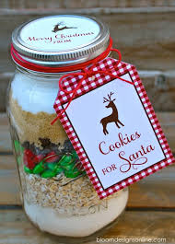

Staff Pick Recipe of the Month:

Mint Chocolate Chip Cookies in a Jar

Layer the following in this order:

* 1/2 C Sugar
* 1/2 C brown sugar
* 1/4 C cocoa powder
* 1/2 tsp salt
* 1/2 tsp baking soda
* 1 and 1/4 C flour
* 2/3 C chocolate chips
* 2/3 C peppermint chips (Any sort of mint chocolate should work.)

Mrs. Rodgers is a teacher in sixth grade. She was born on March 24. Her favorite book is called “Wonder” by Palacio. Five adjectives she would use to describe herself are short, sarcastic, shy, humorous, and helpful. Her favorite things to do outside of school are camping and spending time with her family. She loves P.E. and math. Mrs. Rodgers had always wanted to be a teacher, but wanted to be a journalist, and then became a teacher. Her favorite season is summer because it is warm. She graduated college from two places- Westminster College and Western Governors University. She loves Italian food and loves the color teal. She is married with three kids, 2 boys and one girl. The two boys’ names are Kyson and Keegan, ages 8 and 5, and the girl’s name is Brooklyn, and she is three years old. These are some things about Mrs. Rodgers.

Meet Mrs. Rodgers

Winter 2016

The Lorem Ipsums