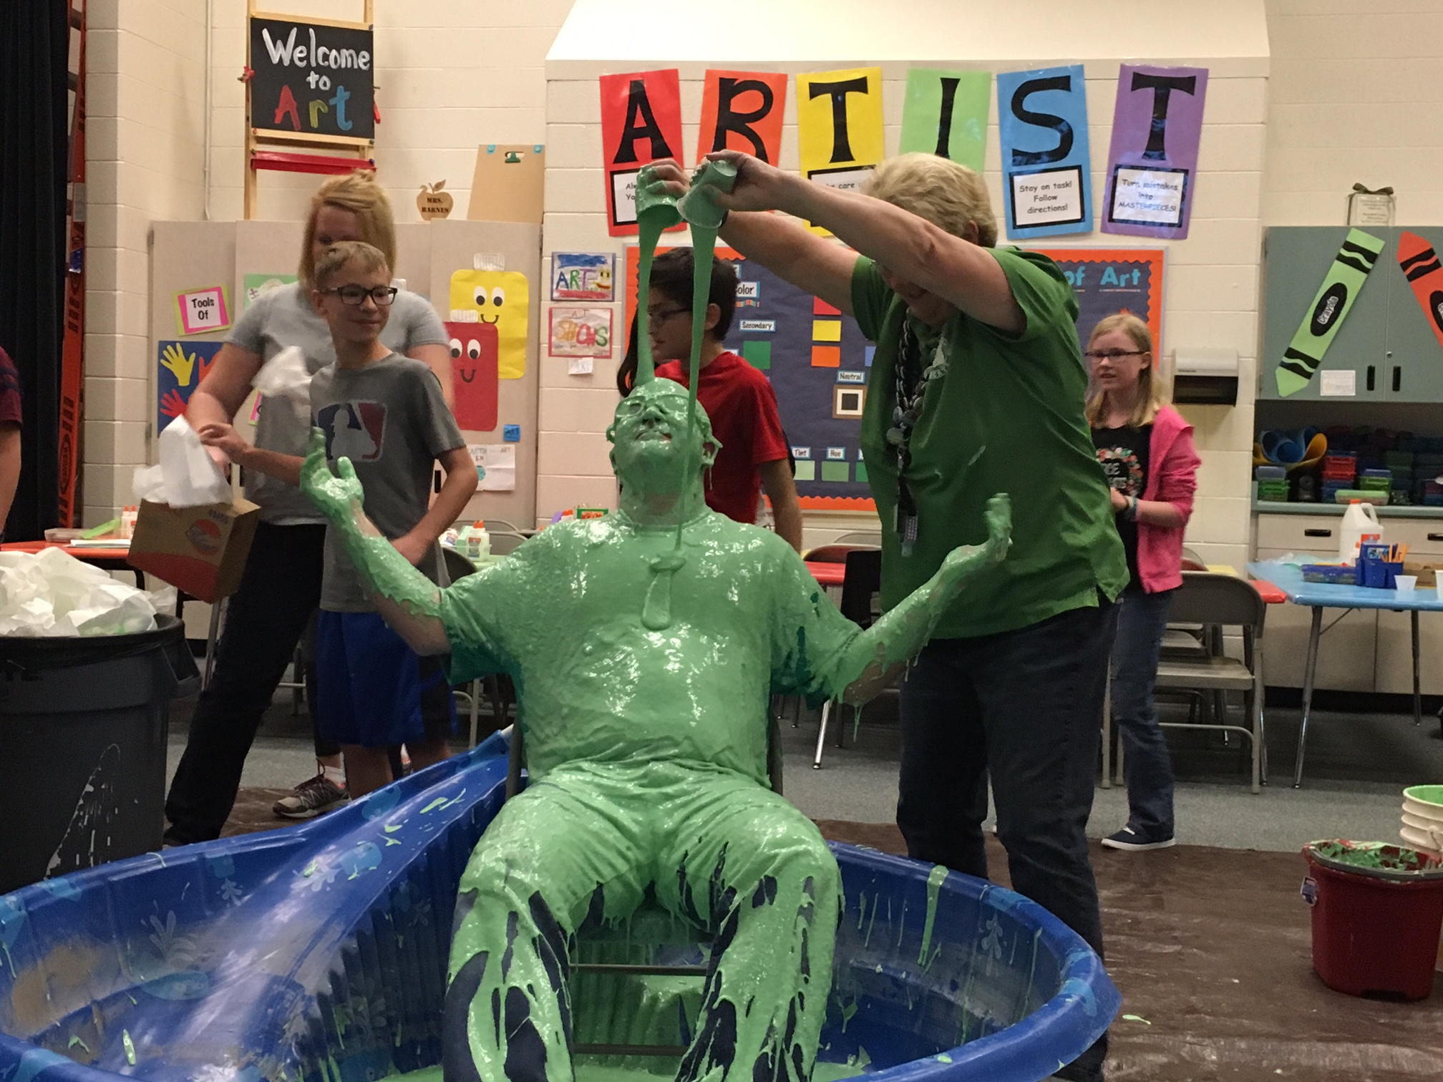

Dear Bobcats,

Wow! It's been fun couple weeks at BCE! I'm looking forward to a week when I don't get slimed or pied in the face.  Congratulations to everyone who participated in our Battle of the Books. As a school we demolished our goal by reading over 500,000 pages. Silver Crest teams were tough, but we'll have to dig in deep so that we can take back the trophies next year! Way to go Bobcat Readers!

I am really looking forward to the Science Bee and Math Wars coming up for the upper grades. You will each be getting a study guide from your teacher. Please take time to study the math and science content so you can be sure you've mastered it all before you move on next year. Just as a reminder to those of you out there who are on the fence, trying to decide if you're actually going to make studying for this a priority - we have a magician booked for an assembly in May that all students who get an 85% or higher will be invited to. We also have some kindle fires and trophies for the top scientists and mathematicians from each grade who compete and rank in the final assemblies. Did you know that dressing up in your favorite Star Wars attire is okay and encouraged for Math Wars? Light Sabers are okay, but please no blasters.

As you will be taking the SAGE tests on the computer when you come back from Spring Break, remember that taking a test is simply an opportunity to show what you know. Don't stress out. Just do your best and rock the test! You've been working hard all year long and learning a ton of new things. These tests are just a way to show your parents, teachers, and yourselves what you really know. I am confident that you'll do great! Remember that you should only compare your performance with yourself. The goal is to make individual progress, not to get better than someone else. When you make progress and improvements - let's celebrate that and keep it going. You've got this!

- Mr. Hansen

The Bobcat Bulletin

April 2017

April 10-14: Spring Break

April 18: 4th-6th Science Bee Test

April 20: 3rd grade spelling bee

April 21: 4th-6th Science Bee

April 24: 4th grade field trip

April 28: Leadership Breakfast

Important Upcoming Dates:

Principal’s Corner

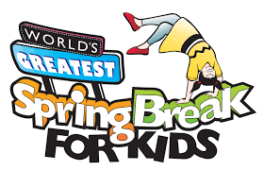

Some ideas to make a great Spring Break

History of the Easter bunny

By: Emma

Do you know about the Easter Bunny? Did you know that he actually came from German immigrants who came to Pennsylvania . His original name was Osterhase. Easter baskets were originally nests were the Easter Bunny would lay colorful eggs. I thought that platypus were the only mammals that could lay eggs. The later were traded for baskets but he hide the eggs instead of laying them. He has always used candy in the baskets with the eggs

Hey everybody! It’s your reporter, Kenadee King here with another newsletter! I have gathered some great ideas to make your spring break unforgettable. Spend time with your family of course! Go swimming at any INDOOR pool, play outside with friends and family, bake, do service, for example: make cookies for new neighbors or people that you have not seen in a long time. Also, write letters to family and friends that you can’t, just talk to like neighbors.” Play with sister(s), brother(s), aunt, uncle, cousin etc. Have some sort of sale, for example: Bake sale, snack sale, lemonade sale etc. You can do many other things too!!! Get creative!

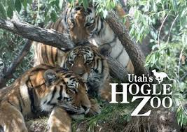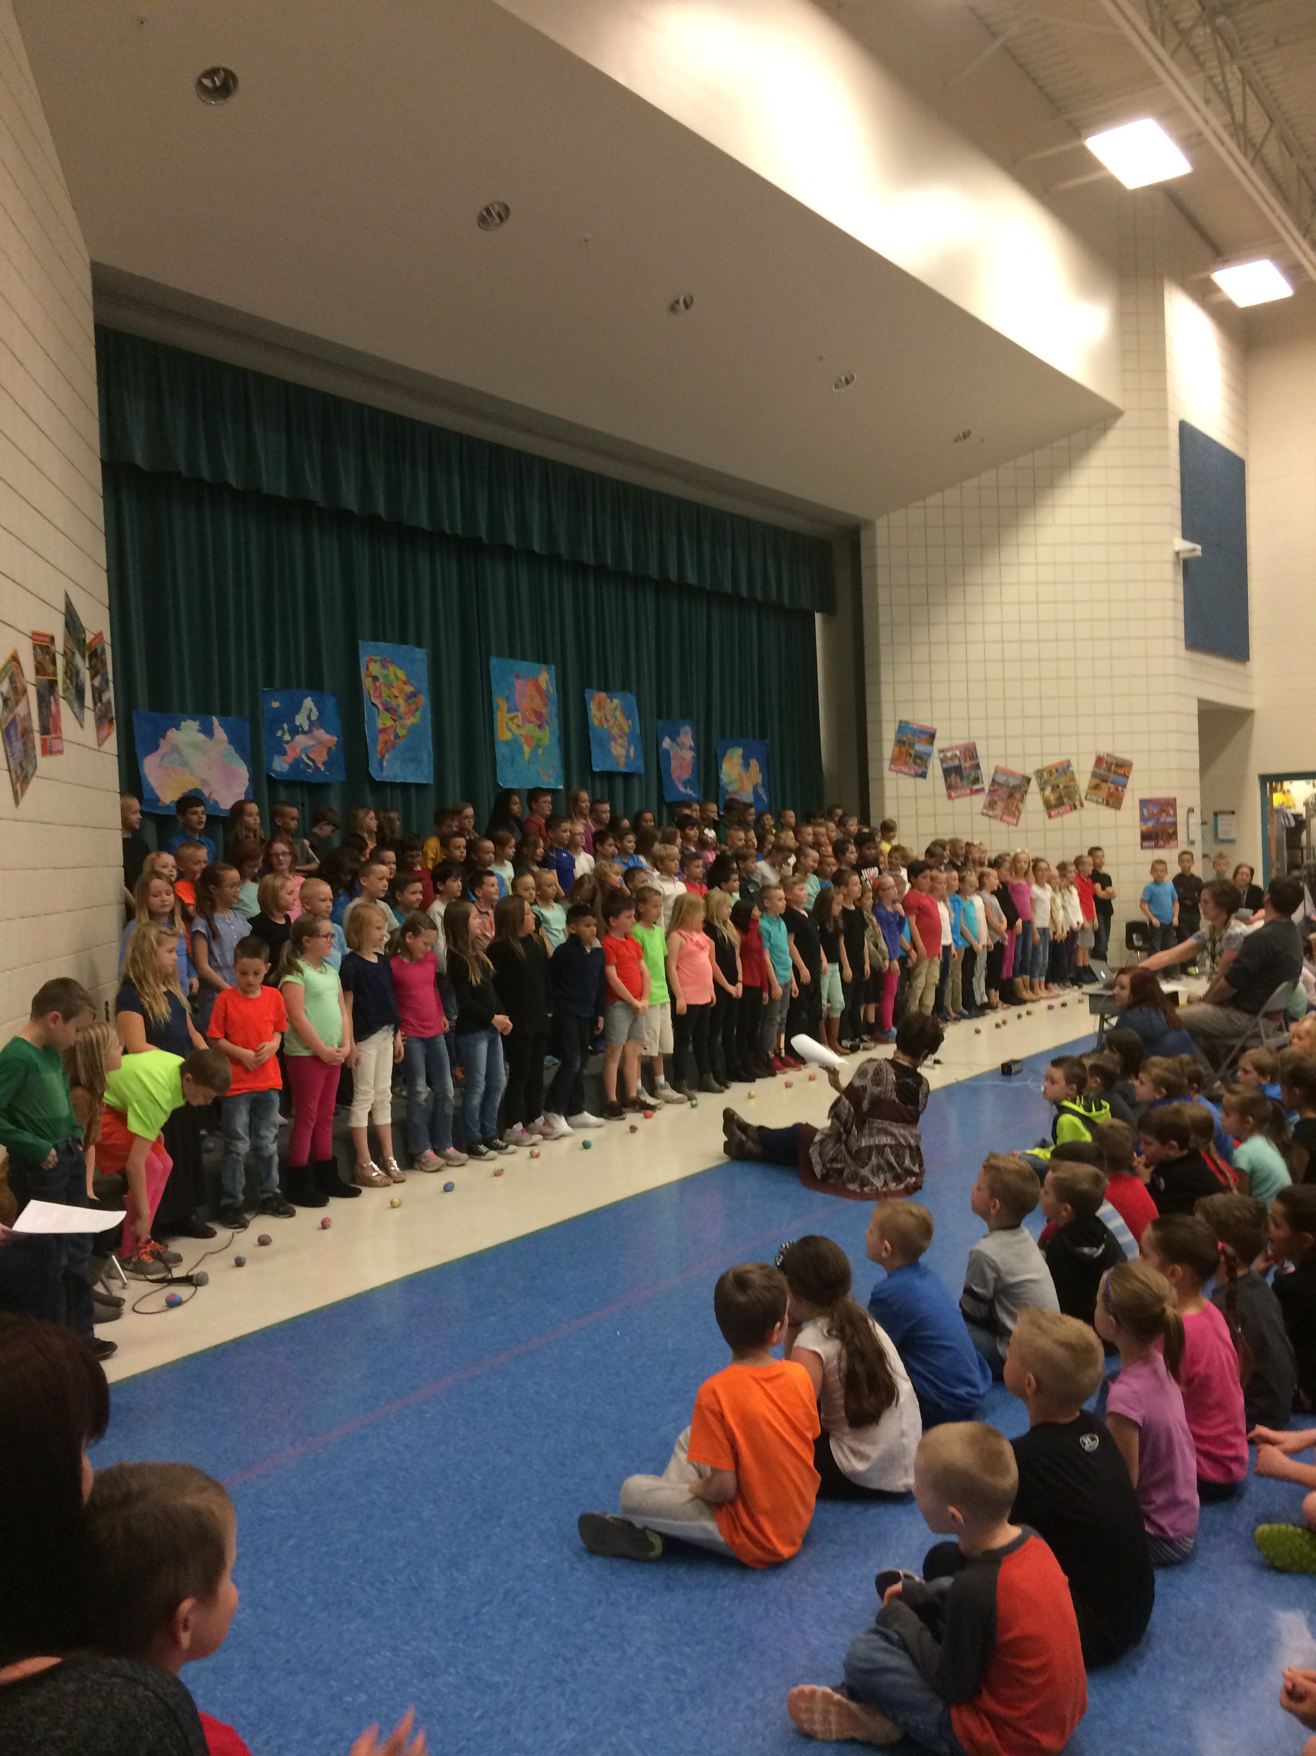

First Grade field trip

The Zoo

By Channing Rose Sleater

On Wednesday, March 22nd, the first grade went on a field trip to the zoo. The first thing we did was to get on the bus and we got to sit by our friends. It was fun because a lot of us got to bring our parents. When we got there we saw a lot of animals. Some the animals we saw were sea lions, zebras, elephants, giraffes, bears, tigers, gorillas, monkeys, snakes, turtles, and bald eagles. The weirdest animal I saw was a skunk! The craziest thing I saw was a little gorilla lunging at and fighting a big gorilla. We all had so much fun and didn’t even rain! I am so glad we got to go on the field trip to the zoo.

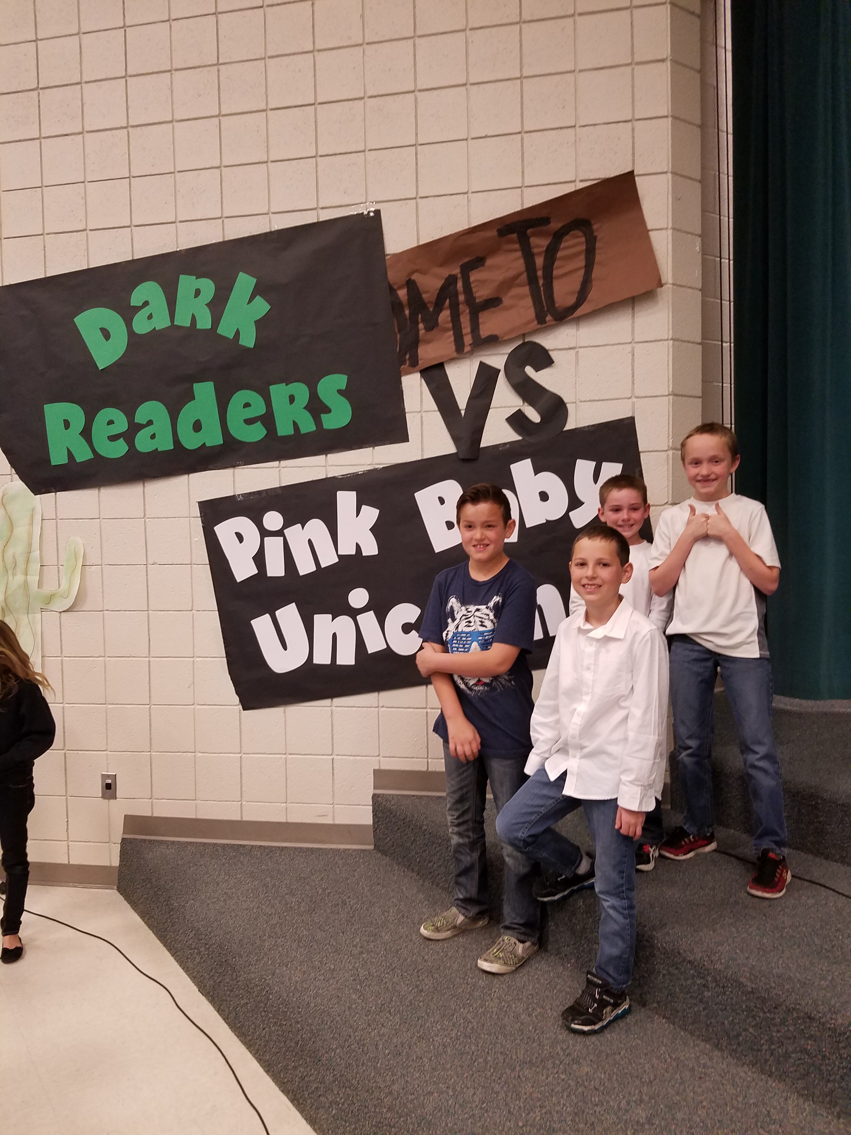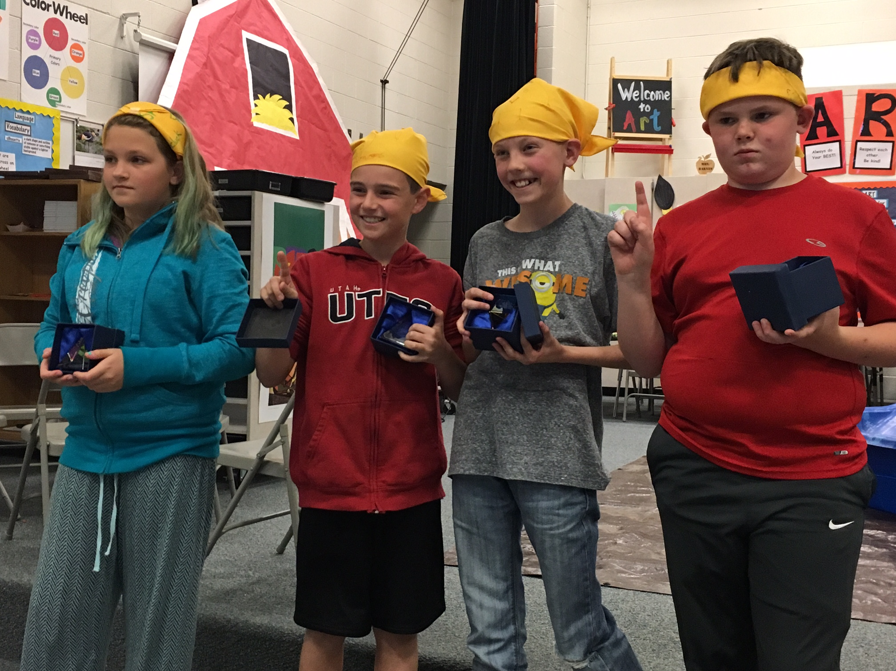

BoB Champions

On April 5th, the 2nd grade had a performance.  It's about different countries.  We'll be singing about continents.  My favorite song is Gumtrees.  It's a song from Australia.

Kestler Hagen

Second Grade Program

From our first song to our last we sing songs from all over the world.  Our speaking parts tell about the songs and the countries.  My favorite song we sing is Gumtrees.  Australia is home to the koala, kangaroo, emu, kookaburra, and platypus.

By Kyson Rogers

Second grade

BOB Finals

By Olivia Dinkelman

         This year’s battle of the books was epic. There are two reading lists, the Third and Fourth Grade list, and the Fifth and Sixth Grade list. Four BOB groups went through challenging battles to become BOB Finalists. For the third and fourth grade list, both finalists were from third grade! Team One was the “Dark Readers”, which included Ryan, Kaden, Leroy, and Aiden. Their opposing team, team two, was the “Black Bobcats”, who was Maggie, Mathew, Kylie, Danika, and Jacob. Second place for this battle was the Black Bobcats with 42 points. First place was the Dark Readers with 105 points. For the Fifth and Sixth grade BOB battle, one team was fifth grade; the other was sixth grade. Team one was the “Shadow Chickens”, which included Addie, Parker, Colten and Seth. from Mrs. Masina’s class. Team two was the “Furious Four” which included Chet, Charlotte, Grace, and Braxton from Mrs. Joos’ class. The Shadow Chickens won with 91 points, and Furious Four was second place with 63 points. At the end of the battles, Mr Hansen slid through a pool of slime because we reached our goal of 300,000 BOB Book pages read. We even went over our goal and read approximately 500,000 pages! Later the next week, our BOB winners battled Silvercrest. We lost both battles, so our principal got 2 pies to the face. Good job Bobcats for reaching our goal, and great job BOB finalists.

Preparing for Sage

By Tyler Betteridge

As you all know, end of the year SAGE testing is coming up.  It is IMPORTANT to study, so here are a few tips to help you:

1. Study a little bit each day for a few weeks leading up to it.  It’s easier to remember one thing each day than to try to stuff all the information into one day and be done.
2. Take a break the night before SAGE and get a good night’s rest.  It’s important to be sharp and well rested so you can remember what you learned.
3. Eat a good breakfast. It helps with your health and makes your mind sharper.
4. Read all directions carefully.  It’s crucial to read the directions carefully.  You don’t want to misunderstand a question.
5. Read all the answers before you choose one in case there’s a better one.

Good luck!! 

Our Assistant Principal, Mrs. Bollinger

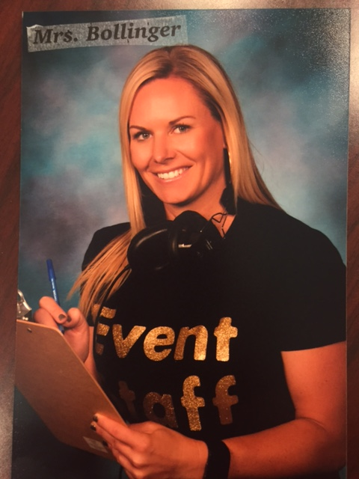

By:

Caroline Morris

This month I interviewed our vice principal, Mrs. Bollinger. I asked her some questions and this is how she responded:

Question: What is your favorite color?

Answer: Yellow, because it is so bright and happy.

Q: What is your favorite food?

A: Chicken

Q: What is your best part of your job?

A: Working with kids

Q: What is your favorite animal?

A: Cat

Q: What is your favorite flavor of ice cream?

A: Rocky Road

Q: Is there anything else you want to tell me?

A: I love to work at Butterfield Canyon. There are amazing teachers and awesome students here. I Love my job.

Well, there you have it. Now we all know a little bit more about our vice principal, Mrs. Bollinger, here at Butterfield Canyon.